**WEB-BASED ACADEMIC GUIDE**



Arranged by :

Afdhal Kurniawan 1606877616

Cahyadi Bayu Saputro 1606835172

Lutfhi Faishal 1606830474

COMPUTER ENGINEERING

FACULTY OF ENGINEERING

UNIVERSITY OF INDONESIA

2018

**PREFACE**

We praise and gratitude to Allah SWT., so that we could complete this first project documentation well. Although we meet obstacles by many things, but we are grateful that we still be able to write this project documentation.

The basics of programming is very important, which is needed before developing things in software and computer hardware. By programming, we are trained to be able to think logically, systematically, but also creative. Nowadays, so many unique applications that really help human to do anything faster and more efficient.

As a student of Computer Engineering, the authors wanted to have superior capabilities and contribute by make a project. As first step, and also to fulfill the task of this documentation, the authors will try to make a project about logic learning games for children and hope it will be communicative, easy to use, and highly useful. We also thanked to Prof. Dr. Ir. Riri Fitri Sari, M.Sc., MM. who has been guiding for learning and assist the preparation of this project documentation.

This final documentation is still very far from perfect, therefore the authors is expecting criticism and suggestions to improve this work to be implemented better. Finally, the authors hope this article can be useful for readers.

Regards,

Developer Team

**LIST OF CONTENT**

CHAPTER 1 - INTRODUCTION

1. GENERAL PURPOSE
2. USER SPECIFICATION
3. HARDWARE
4. RISK ANALYSIS

CHAPTER 2 - PROJECT MANAGEMENT

1. PROJECT PLAN DEVELOPMENT
2. PROJECT PLAN EXECUTION
3. PROJECT TIME MANAGEMENT
4. PROJECT HUMAN RESOURCE MANAGEMENT
5. PROJECT RISK MANAGEMENT

CHAPTER 3 – UML

1. ACTIVITY DIAGRAM
2. USE CASE DIAGRAM
3. CLASS DIAGRAM
4. SEQUENCE DIAGRAM

**CHAPTER 1 - INTRODUCTION**

1. GENERAL PURPOSE

The purpose of our project is to provide information about academic especially for student in University of Indonesia in the form of Website that is mobile-friendly, so everyone can see it whenever and wherever they want even if they use smartphone.

The information that we will provide is in the form of academic information that can help students inconducting their studies. The information in question include general information such as procedure for new student, how to fill IRS, how to use facilities and many other.

To be able to see this Academic Guide, students can use a laptop or smartphoe that has a web browser in it.

1. USER SPECIFICATION

This website can be used for students who are looking for information about the problems of their studies.

1. HARDWARE

- PC/Laptop

1. RISK ANALYSIS

The biggest risk of our project is the completeness of information articles that we can collect. The lack of complete information will make it difficult for students to find the information they need.

**CHAPTER 2 - PROJECT MANAGEMENT**

1. PROJECT PLAN DEVELOPMENT

The website that we created can cover every aspect that existed in Administrative Environment University of Indonesia so it can support and facilitate student in obtaining information in Campus Environment especially information about administrative activities at the University level or Faculty level.

1. PROJECT PLAN EXECUTION

• XAMPP is used to make a localhost so we can test the website that we created

• PHP and HTML is used as a programming language to make a website

• JQUERY Mobile is an add on to make the website has a feature of mobile-friendly

1. PROJECT TIME MANAGEMENT

**Table 2.1 Project Time Management Table**

|  |  |  |  |
| --- | --- | --- | --- |
| Task name | Start Date | Finish | Duration |
| 1. Learning the Programming Language | 16-9-2018 | 14-10-2018 | 30 days |
| 2. Collect Information | 7-10-2018 | 28-10-2018 | 21 days |
| 3. Design the website | 29-10-2018 | 18-11-2018 | 21 days |
| 4. Trial and Evaluation | 19-11-2018 | 23-12-2018 | 30 days |
| 5. Finishing | 24-12-2018 | 31-12-2018 | 7 days |

**Figure 2.1 Project Timeline**

|  |  |  |  |  |  |  |  |  |  |  |  |  |  |  |
| --- | --- | --- | --- | --- | --- | --- | --- | --- | --- | --- | --- | --- | --- | --- |
| Tugas | September | | Oktober | | | | November | | | | Desember | | | |
| 3 | 4 | 1 | 2 | 3 | 4 | 1 | 2 | 3 | 4 | 1 | 2 | 3 | 4 |
| 1. Learning the Programming Language |  |  |  |  |  |  |  |  |  |  |  |  |  |  |
| 2. Collect Information |  |  |  |  |  |  |  |  |  |  |  |  |  |  |
| 3. Design the website |  |  |  |  |  |  |  |  |  |  |  |  |  |  |
| 4. Trial and Evaluation |  |  |  |  |  |  |  |  |  |  |  |  |  |  |
| 5. Finishing |  |  |  |  |  |  |  |  |  |  |  |  |  |  |

1. PROJECT HUMAN RESOURCE MANAGEMENT

This table show our agreement about responsibilities division for completing this project. But if someone meet a trouble in that division so we have to help each other.

**Table 2.3 Project Human Resource Table**

|  |  |  |
| --- | --- | --- |
| **Name** | **Role** | **Description** |
| Afdhal Kurniawan | Project Leader, Designer, Programmer | * Lead and Guide the Team * Develop Program * Design GUI * Create Documentation |
| Cahyadi Bayu Saputro | Programmer, Secretary, Program Developer | * Develop Program * Analysis and Develop program feature * Create Documentation * Lead the Non Technical Things |
| Lutfhi Faisal | Main Programmer, Program Developer | * Develop Program * Analysis and Develop program feature * Create Documentation * Lead The other Programmer |

1. PROJECT RISK MANAGEMENT

To overcome the risk of incomplete information or the information needed is not contained in the website created, therefore we will conduct a survey of several active students in each generation to find out that students in Indonesian universities need any information and surveys it will be summarized in a table so that it can be grouped. This is expected to help us in providing complete and detailed information on the website that we created.

1. PROJECT COMMUNICATION MANAGEMENT

To be able to communicate we will use Smartphones and Computers. For Smartphone we will use the LINE, Whatsapp and other applications to communicate.

**CHAPTER 3 – UML**

UML (Unified Modelling Language) diagram is used to develop the Academic GuideApp. The UML diagram consist of nine diagrams which could be implemented to model the application.

1. ACTIVITY DIAGRAM

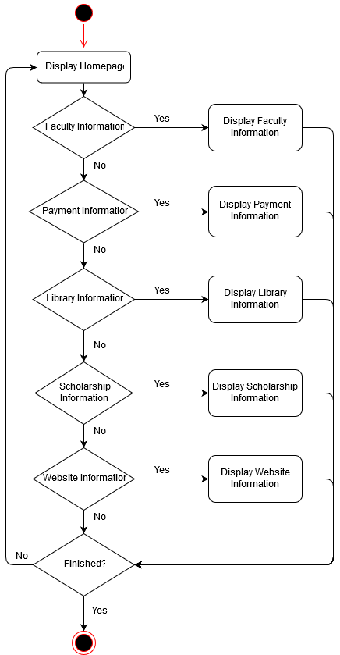

1. USE CASE DIAGRAM

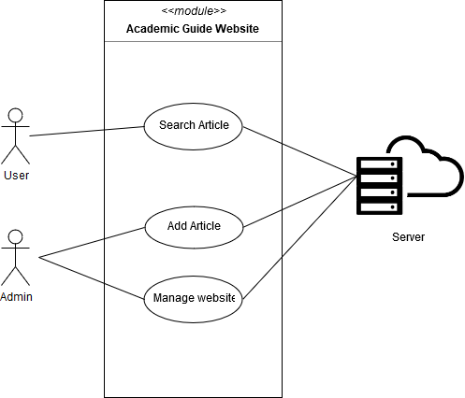

1. CLASS DIAGRAM

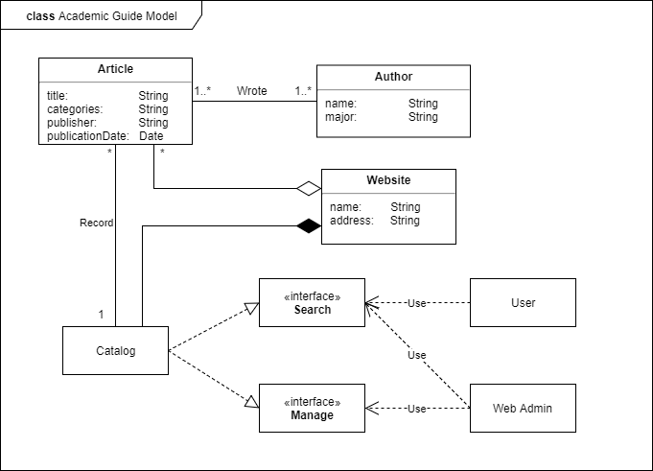

1. SEQUENCE DIAGRAM
2. Sequence Diagram by Categories

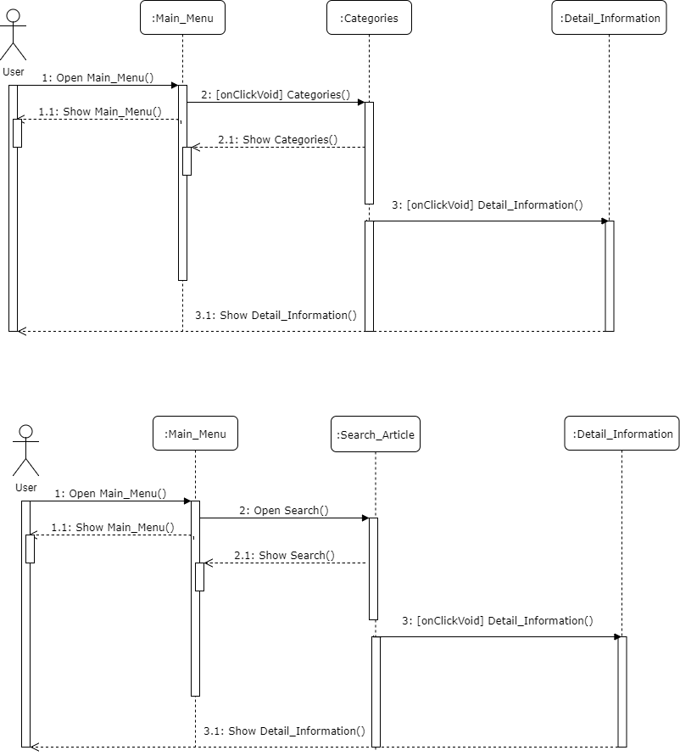

1. Sequence Diagram by Search

